International Debt Analysis

Chiranjeevi Mallavarpu, Ramya Mandava, Sabitri KC, Kim Wong
Southern Methodist University
Dallas

Abstract: The World Bank International Debt dataset provides the detailed picture of debt stocks and flow data on the external debt of individual low and middle income countries. It also showcases other debt data collected and compiled by the world bank so we were able to analyze the statisctics of highest and lowest debt country, the category of highest debt across different countries and check their patterns.we were also able to explore if the income level has any effect on the overall debt of the country.The data was accessed via world Bank data portal https://data.worldbank.org/data-catalog/international-debt-statistics and MySQL on IBM bluemix is used to extract all the insights of this dataset.(summary of the work)

1.Introduction
Developing countries has been growing enormously since the early 1970s. To meet the demand of the exponential growth, developing countries have drastically expanded their debt burdens. With globalization, the impact resulted from inability to pay back no longer limited to the same geographic area. With the international financial system highly interconnected, thus systematic instability caused by a country’s debt crisis will send a ripple effect through the world economy and leads to losses to investor and slow the global economy. An example is the Asian financial crisis in 1997, which started in Thailand as the country had extensively borrowed in U.S. dollars.

The International Debt statistics contains more than 200 debt and financial flows indicators for over 130 countries that report public and publicly-guaranteed debt to the World Bank reporting system. The database runs from 1970 to 2016 and pipeline data for scheduled debt service payments on existing commitments to 2024.The database covers external debt stocks and flows, major economic aggregates and key debt ratios as well as average terms of new commitments, currency composition of long term debt, debt restructuring and schedules debt service projections.

2. Our work

2.1 SQL code link at github

https://github.com/skc00/DBMS-Term-Project/blob/master/SQLScript_Output.docx

2.2 GitHub link for tutorial
https://github.com/skc00/DBMS-Term-Project

2.3 Hardware experimental Specifications
Database server we are using for this analysis is MySQL on IBM bluemix. Data size is about 155MB and memory size is about 1GB.
The dataset includes 5 tables:

- country_series_definitions
- country_summary
- international_debt
- series_summary
- series_times

Detailed description of the tables is available at https://bigquery.cloud.google.com/dataset/bigquery-public-data:world_bank_intl_debt

The major indicator the analysis focusing on is DT.DOD.DECT.CD (External debt stocks, total (DOD, current US$) defined as debt owed to nonresidents repayable in currency, goods, or services. Total external debt is the sum of public, publicly guaranteed, and private nonguaranteed long-term debt, use of IMF credit, and short-term debt. Short-term debt includes all debt having an original maturity of one year or less and interest in arrears on long-term debt. Data are in current U.S. dollars. ^{[1]}

Figure 1.1World Bank International Debt Classification
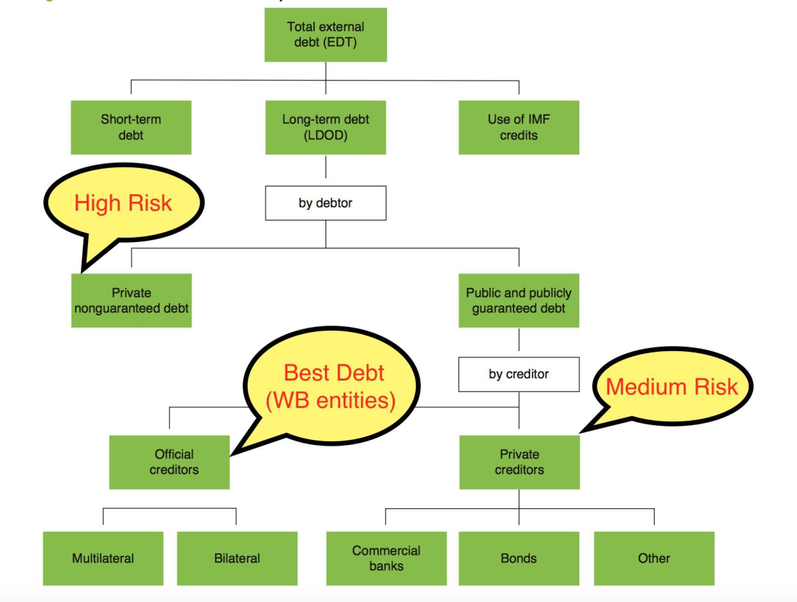

3. Related / Existing Work
While Google analysis is about Present Value of External Debt (lifetime), we focus on debt outstanding as of Year 2016. This is to minimize the needs to make assumptions on what is the relevant rate to discount specific currency. given country-specific circumstances and changes that may happen over the life of the debt. In addition, 2016 has the most complete data to date for most countries.

We also exploring new perspective, analyzing metrics such as debts via official creditors vs private non-guaranteed, income level of the country and distribution of most owned debt categories. This will further expand our understanding of relationship of debt performance and income levels of a country

4. Conclusion

The International Debt dataset from world bank website was analyzed and found some important insights. China seems to have the highest external debt^{[2]} i.e.$1, 430 Billion across all^{[2]} countries. Tonga(a Polynesian island) seems to have the lowest external debt^{[2]} i.e.$159.855 Million across all^{[3]} countries.

Figure 4.1 External Debts by Countries
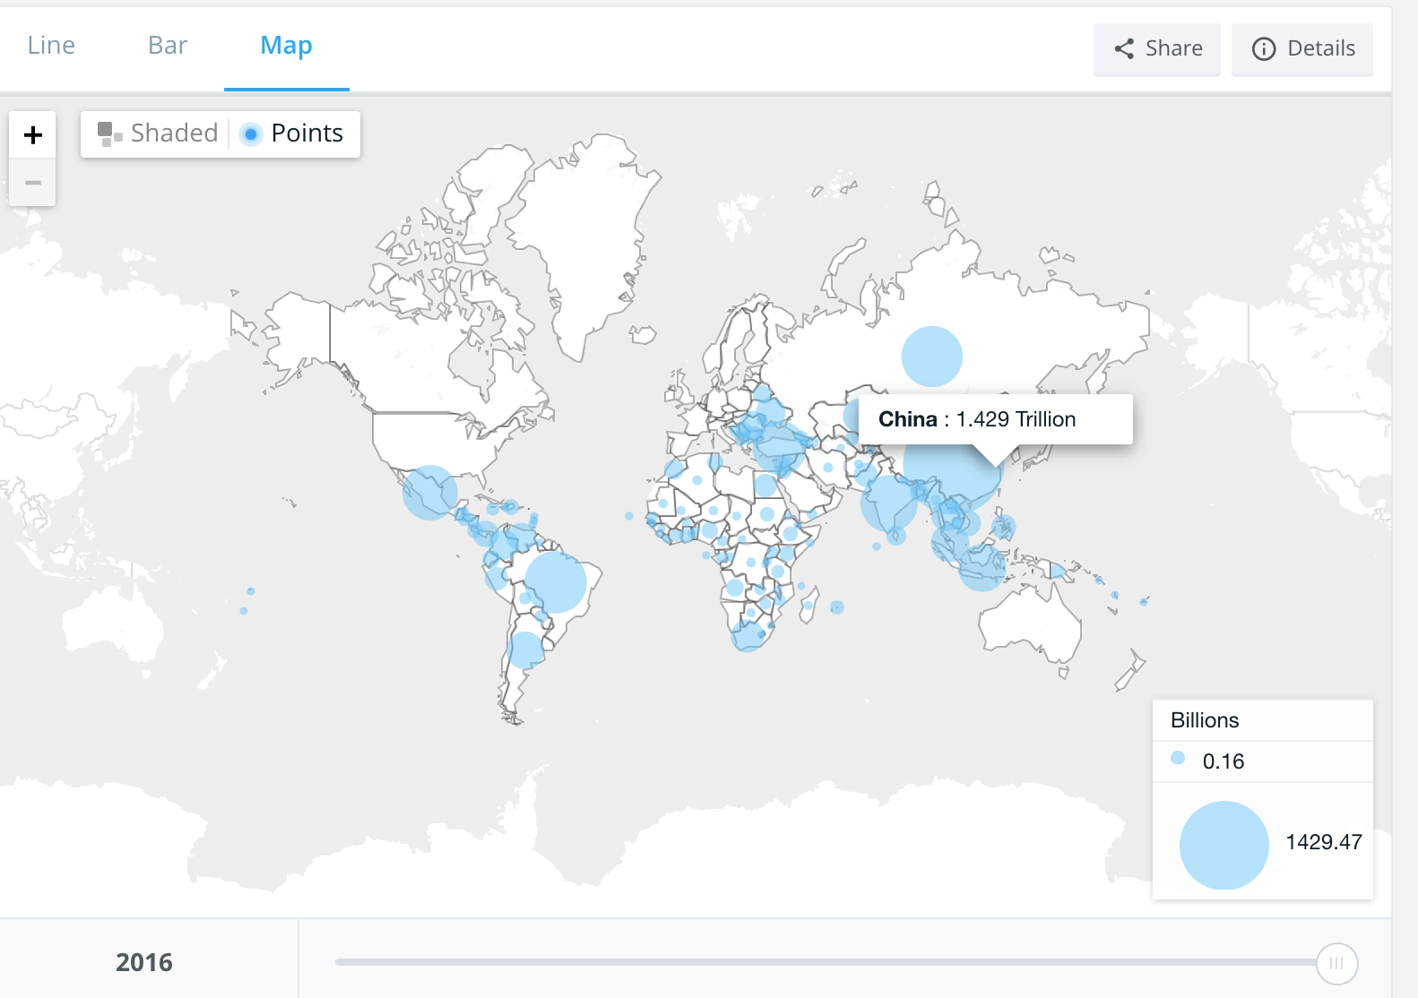
Table 4.1 Top 5 Countries with largest external debts
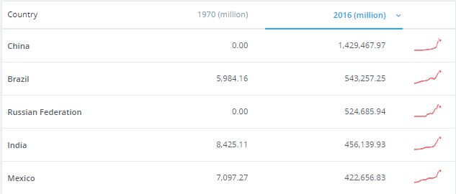

Figure 4.1 China: External Debts vs. GDP
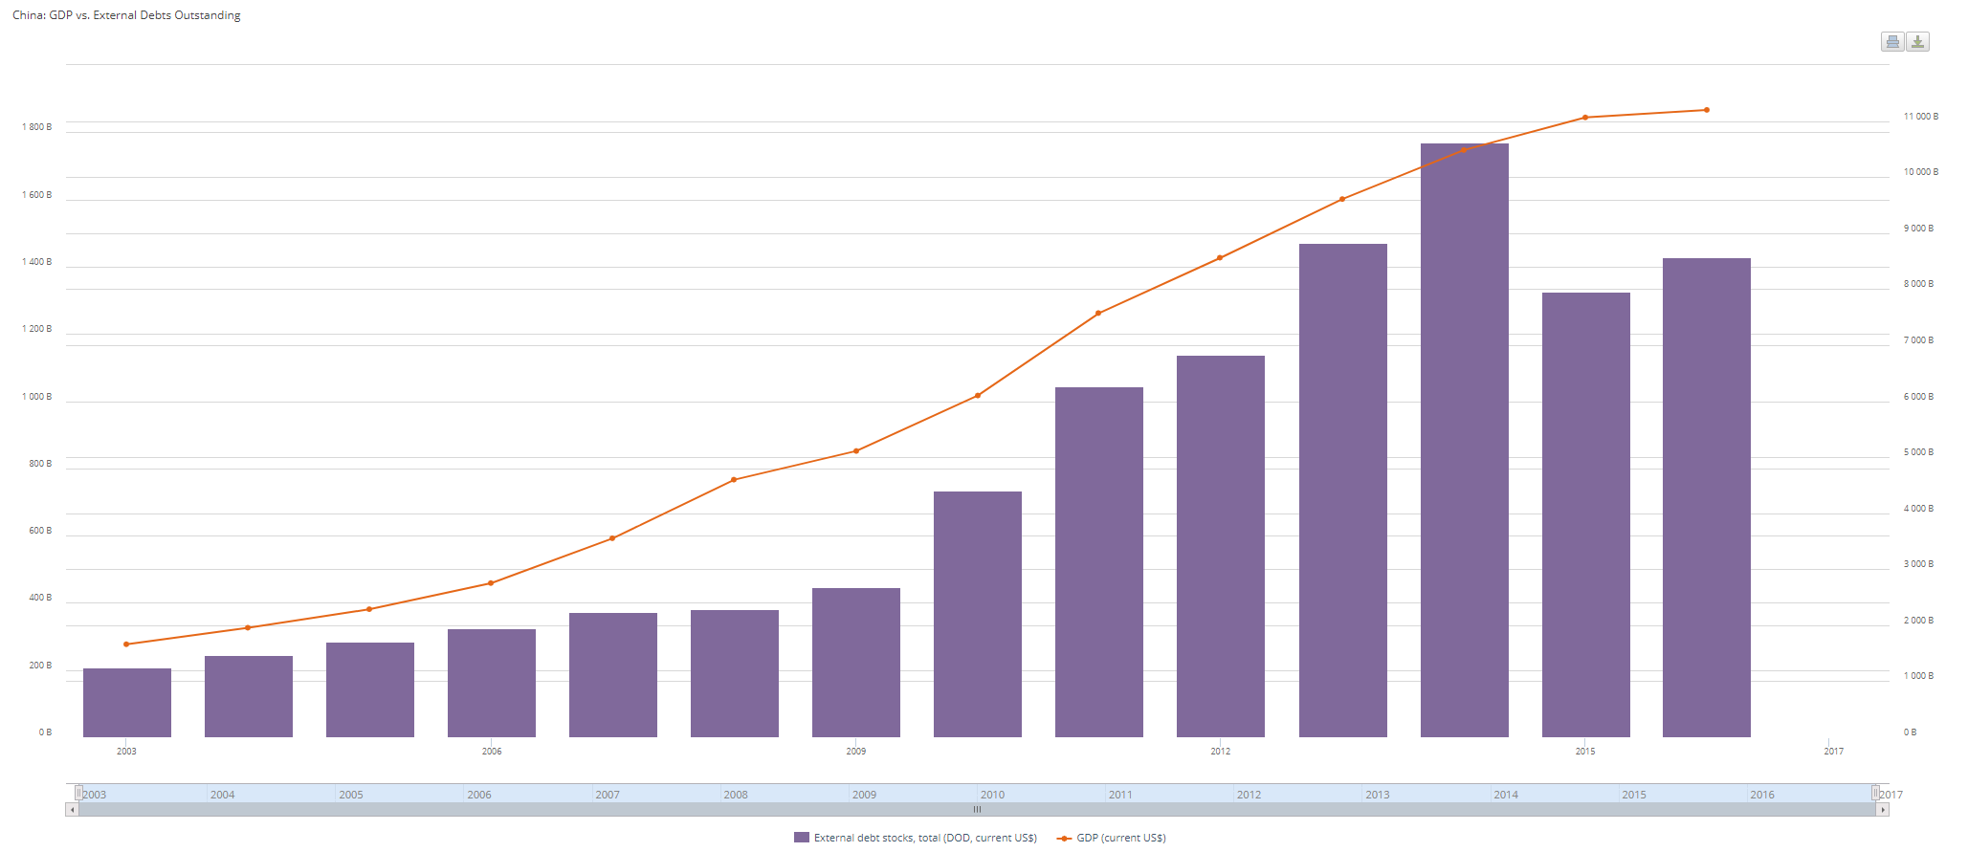
The findings were inline with heavyuse of credit (due to favorable interest rate to fuel the rapid growth in China recent years. The country’s debt has ballooned to almost 250% of GDP . On an average long-term external debt seems to be highest across all^{[3]} countries. Within long-term debt, private non-guaranteed category contributes majorly towards the international debt(49.4%). Official creditors (World Bank entities) contributing least (20%).The average debt of countries with Upper middle income level seems to be highest(64%) among all the countries and Low income level seems to be the least.

References
[1]https://www.investopedia.com/ask/answers/051215/how-can-countrys-debt-crisis-affect-economies-around-world.asp
[2] https://cloud.google.com/bigquery/public-data/world- bank-international-debt#about_the_data.
[3] https://data.worldbank.org/data-catalog/international-debt-statistics

(summarize what you have did, why your work is interesting or important, what you have built and what you learned from the wrk

Source: World Bank, International Debt Statistics 2 External debt comprises of long-term debt, short-term debt, use of IMF credit 3 The countries in scope for this exercise are only those countries that are developing countries (low and middle-income) and report debt to World bank – excludes USA, Canada, Greenland and some of the European countries

